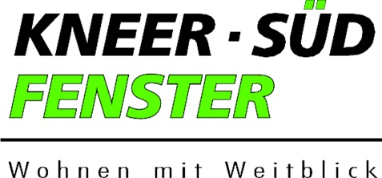

New windows and front doors available from Kneer-Südfenster: Hall 5, booth 5-121

Inspired by Scandinavian Design

The new exhibition booth of Kneer-Südfenster at the Fensterbau Frontale 2020 quotes many elements of Scandinavian interior design, including bright, friendly colours, clean lines, and lots of wood, united in a highly modern design language. Open on all sides, the booth invites exhibition-goers to drop in on this manufacturer of windows and front doors from Westerheim and Schnelldorf, Germany, and get inspired by new ideas. With their straight lines, understated and highly functional design, and flexibility in the ways they can be used, the products of the new portfolio fit beautifully into Scandinavian-style, cosy living spaces.

Convenient all-in-one packages for small façades
The exhibition booth of Kneer-Südfenster also presents a new take on the issue of glass façades, doing away with the idea that it always takes a fully-glazed stick system façade to lighten and brighten a house design. A smaller façade, too, can have a great impact, catching the sunlight and supplying houses and apartments with plenty of natural illumination. The window specialists at Kneer-Südfenster can deliver glass façades that are produced to exact specifications and pre-assembled as far as possible.

All varieties of new windows: window seats,
fixed glazing, lattice windows, and wooden windows for protected historical monuments
Kneer-Südfenster is proud to present a large new picture window with a deep frame that allows it to be used as a window seat. Inviting you to get comfortable on the windowsill and look out the window in the epitome of Scandinavian cosiness, this novelty has the potential to become the new favourite spot in any house.

The all-round manufacturer also provides fixed glazing in large formats perfectly suited to the needs of modern architecture. In addition, there are new, charming designs of lattice windows, such as a wood-filigree lattice window that complements Scandinavian-style living. In contrast, an industrial-style aluminium lattice window is available that is intended to suit modern loft-style apartments. New variants of wooden windows for historical monuments deliver the final proof of Kneer-Südfenster's expertise.

High security with RC3-approved windows
When it comes to protection against burglary, Kneer-Südfenster has achieved a huge step forward with all of its plastic window frame systems from Rehau. These windows have passed inspection by the institute for window technology, ift Rosenheim, and fulfil the exacting requirements of the RC3 certification for high security. The same goes for the aluminium-and-plastic windows from these systems.

New front doors with smart access control systems
Visitors to the Kneer-Südfenster booth can also expect to see new, quality designs for front doors. In addition, a matching selection of the latest access control systems, delivering maximum convenience and security, will be on display. www.kneer-suedfenster.de

Picture captions:

1
The exhibition booth of Kneer-Südfenster at Fensterbau Frontale 2020, to be located in Hall 5, booth 5-121, will spotlight the airiness and clarity of the Scandinavian style of home furnishing.

2
Amongst the novelties to be presented by Kneer-Südfenster will be glass façades and fixed glazing in variants with bright colours and clear-cut shapes to make rooms seem spacious and airy.

Photos: Kneer-Südfenster

Please direct any enquiries to:
Seifert PR GmbH (GPRA), Zettachring 2a, 70567 Stuttgart, Germany –
phone: 0711/77918-0, fax: 0711/77918-77, e-mail: info@seifert-pr.de, web: www.seifert-pr.de

